**ME 111**

**Projection of Solids**

|  |  |  |
| --- | --- | --- |
| 1 | A cylinder 40 mm diameter and 50 mm axis is resting on one point of a base circle on VP while it’s axis makes 450 with VP and FV of the axis 350 with HP. Draw projections. | 30 |
| 2 | A cone of diameter of base 60 mm and axis length equal to 100 mm rests on one of its slant generators on H.P. such that its axis is inclined at an angle of 65° with the V.P. Keep its apex near to the V.P. and draw the projections. | 35 |
| 3 | A hexagonal pyramid of side of base 30 mm and axis length 90 mm rests on one of its slant edge on the H.P. such that the plane containing that slant edge on which it rests on H.P. is inclined at 45° to V.P. and the apex is near to the V.P. Draw the projection of it. | 35 |

**Solution**

**1**

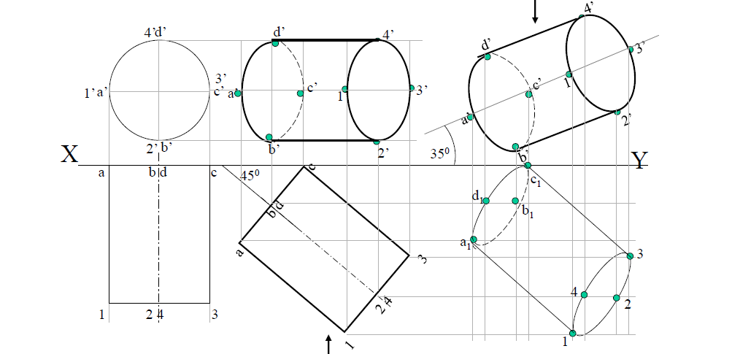

**2**

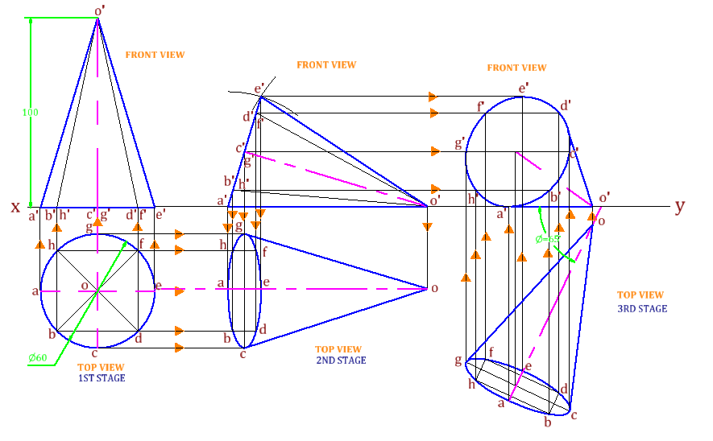

**3**

